**FALLBROOK VILLAS METROPOLITAN DISTRICT**

**ELECTION RESOLUTION FOR 2025 REGULAR DISTRICT ELECTION**

**2025 Resolution No. 3**

**WHEREAS,** the terms of office of Directors KimNichelle Rivera, Todd Geist, Robert Bullion, and Kaitlyn Stroud shall expire after their successors are elected at the regular special District election to be held on May 6, 2025, (“Election”) and take office; and

**WHEREAS,** in accordance with the provisions of the Special District Act (“Act”) and the Colorado Local Government Election Code (“Code”), the Election must be conducted to elect three Directors to serve for a term of four (4) years, and one Director to serve for a term of two (2) years; and

**NOW, THEREFORE,** be it resolved by the Board of Directors of the Fallbrook Villas Metropolitan District, Adams County, Colorado that:

1. The regular election of the eligible electors of the District shall be held on May 6, 2025, between the hours of 7:00 A.M. and 7:00 P.M. pursuant to and in accordance with the Act, Code, and other applicable laws. During that time, three Directors will be elected to serve a four-year term, and one Director will be elected to serve a two-year term.
2. The Election shall be conducted as a mail ballot election in accordance with all relevant provisions of the Code. The Designated Election Official shall develop a Plan for conducting the mail ballot Election, which will be made available to the public. There shall be no election precinct or polling place. All mail ballots shall be returned to the Designated Election Official’s office:

Daniel Rubin

Dietze and Davis, P.C., 2060 Broadway, Suite 400,

Boulder, CO 80302

1. The Board of Directors designates Daniel Rubin as the Designated Election Official for the conduct of the election on behalf of the District, who is hereby authorized and directed to proceed with any action necessary or appropriate to effectuate the provisions of this Resolution and the Act, Code, or other applicable laws. The Election shall be conducted in accordance with the Act, Code, and other applicable laws. Among other matters, the Designated Election Official shall publish the call for nominations, appoint election judges as necessary, appoint the Canvass Board as necessary, arrange for the required notices of election, and printing of ballots, and direct that all other appropriate actions be accomplished.
2. Self-Nomination and Acceptance forms are available at the Designated Election Official’s office located at the above address. All candidates must file a Self-Nomination and Acceptance form with the Designated Election Official no earlier than January 1, 2025, nor later than the close of business (time: 3:00 p.m.) on Friday, February 28, 2025.
3. If the only matter before the electors is the election of Directors of the District and if, at the close of business on March 4, 2025, there are not more candidates than offices to be filled at the Election, including candidates timely filing affidavits of intent no later than March 3, 2025, the Designated Election Official shall cancel the Election and declare the candidates elected. Notice of such cancellation shall be published and posted in accordance with the Code. The Notice and this resolution, signed by the board Chair, shall be filed with the Division of Local Government.
4. If any part or provision of this Resolution is adjudged to be unenforceable or invalid, such judgment shall not affect, impair or invalidate the remaining provisions of this Resolution, it being the Board’s intention that the various provisions hereof are severable.
5. Any and all actions previously taken by the Designated Election Official or the Secretary of the Board of Directors or any other persons acting on their behalf pursuant to the Act, the Code or other applicable laws, are hereby ratified and confirmed.
6. All acts, orders, and resolutions, or parts thereof, of the Board which are inconsistent or in conflict with this Resolution are hereby repealed to the extent only of such inconsistency or conflict.
7. The provisions of this Resolution shall take effect immediately.

ADOPTED and APPROVED, this 16th day of January, 2025, by the Board of Directors of the Fallbrook Villas Metropolitan District, Adams County, Colorado.

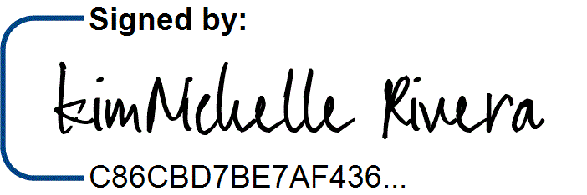ATTEST: FALLBROOK VILLAS METROPOLITAN DISTRICT

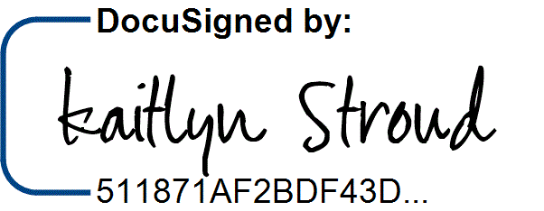

By:

Kaitlyn Stroud, Secretary KimNichelle Rivera, President