**FALLBROOK VILLAS METROPOLITAN DISTRICT**

**RESOLUTION SPECIFYING THE INTENT TO PREVENT POSTING SIGNAGE OF ANY KIND ON PROPERTY OWNED AND CONTROLLED BY THE FALLBROOK VILLAS METRO DISTRICT**

**2025 Resolution No. 4**

WHEREAS, the Fallbrook Villas Metropolitan District wishes to prohibit the posting of signage on District owned or controlled property.

# NOW, THEREFORE, BE IT RESOLVED BY THE FALLBROOK VILLAS METROPOLITAN DISTRICT, THAT:

No signage of any kind or nature shall be placed or installed on property which is owned or controlled by the District. It is the intent of this resolution to prevent any placement of any signs, which can detract from the quality of the appearance of District-owned property, could interfere with the maintenance of that property, and which could impact the value of that property, but to impose this restriction without regulating the content of any signage, and to narrowly tailor this restriction to only that property which is owned or controlled by the District. Any signage or other personal property of any kind or nature which is placed upon property which is owned or controlled by the District, may be removed by the District and may be disposed of immediately.

ADOPTED, this 20th day of February, 2025.

# FALLBROOK VILLAS METROPOLITAN DISTRICT

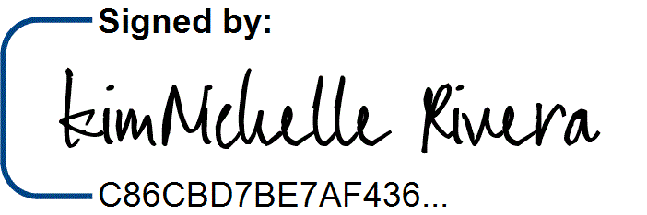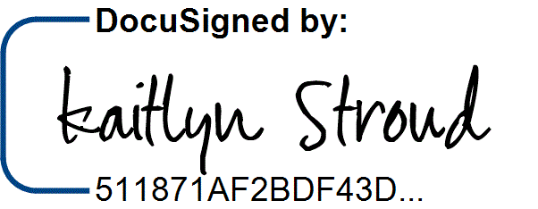ATTEST:

Kaitlyn Stroud, Secretary

By: KimNichelle Rivera, President