**FALLBROOK VILLAS METROPOLITAN DISTRICT**

**RESOLUTION**

**APPOINTING A DESIGNATED ELECTION OFFICIAL AND AUTHORIZING DESIGNATED ELECTION OFFICIAL**

**TO CANCEL ELECTION**

**2025 Resolution No. 2**

32­1­804(2), 1­13.5­513, 1­11­103(3) C.R.S..

**WHEREAS,** pursuant to 32­1­804(2), C.R.S., the Board of Directors of the Fallbrook Villas Metropolitan District, Adams County, Colorado is authorized to designate a Designated Election Official to exercise the authority of the Board in conducting the election, and

**WHEREAS,** pursuant to 1­13.5­513, C.R.S., the Board can authorize the Designated Election Official to cancel the election upon certain conditions;

**NOW THEREFORE,** be it resolved by the Board of Directors of the Fallbrook Villas Metropolitan District, Adams County, Colorado that:

1. The Board hereby names Daniel Rubin as the Designated Election Official for the regular special district election scheduled for the 6th day of May, 2025.
2. The Board hereby authorizes and directs the Designated Election Official, if the only matter before the electors is the election of persons to office, to cancel said election and declare the candidates elected, if at the close of business on the sixty­third day before the election there are not more candidates than offices to be filled, including candidates filing affidavits of intent to run as write­in candidates.
3. The Board further authorizes and directs the Designated Election Official to publish and post a Notice of Cancellation of Election on the District's website, and in the offices of the Designated Election Official, the County Clerk and Recorder of each county in which the district is located, and file it with the Division of Local Government. The Designated Election Official shall also notify the candidates that the election was cancelled and that they are elected by acclamation.
4. Pursuant to C.R.S. 1­11­103(3) and 1­13.5­513(1)&(4), if the DEO has cancelled the election, the DEO or district will file this resolution, together with the Notice of Cancellation, with the Division of Local Government.

ADOPTED and APPROVED, this 16th day of January, 2025, by the Board of Directors of the Fallbrook Villas Metropolitan District, Adams County, Colorado.

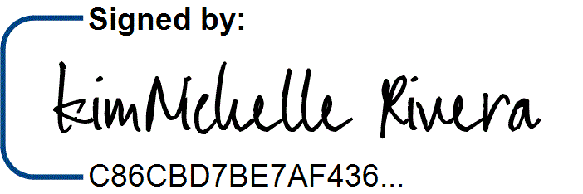ATTEST: FALLBROOK VILLAS METROPOLITAN DISTRICT

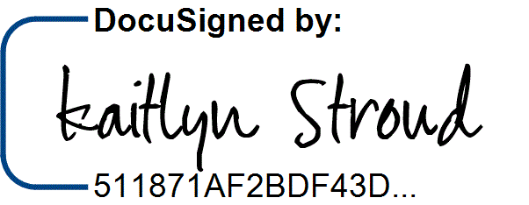

By:

Kaitlyn Stroud, Secretary KimNichelle Rivera, President