**FALLBROOK VILLAS METROPOLITAN DISTRICT**

**RESOLUTION SPECIFYING THE LOCATION WHERE NOTICES OF PUBLIC MEETINGS AT WHICH FORMAL ACTION**

**MAY BE TAKEN ARE TO BE POSTED**

**2025 Resolution No. 1**

WHEREAS, Colo. Rev. Stat. §24-6-402(2)(c) establishes open meeting requirements for local public bodies, which are part of the State's "Sunshine Act;" and

WHEREAS, the Fallbrook Villas Metropolitan District wishes to comply with these provisions of law by designating an area where its notices of public meetings are to be posted.

# NOW, THEREFORE, BE IT RESOLVED BY THE FALLBROOK VILLAS METROPOLITAN DISTRICT, THAT:

Notices designating the time and place for a regular or special meeting shall be posted pursuant to the State's "Sunshine Act," on the District’s website, [www.fallbrookvillas.com](http://www.fallbrookvillas.com/), no less than twenty-four hours prior to such meeting; and

In the event of exigent or emergency circumstances in which a notice of meeting cannot be posted on the District’s website, the notice of meeting shall be posted at the pavilion located at the intersection of E. 141st Avenue and Jackson Street, Thornton, Colorado no less than twenty-four hours prior to such meeting; and

The regular meetings of the District will be held via telephone and videoconference. The call-in number is (669) 444-9171 or Meeting ID is 461 381 5754, passcode 6743379.

ADOPTED, this 16th day of January, 2025.

# FALLBROOK VILLAS METROPOLITAN DISTRICT

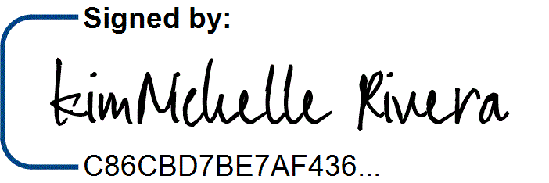ATTEST:

By: KimNichelle Rivera, President

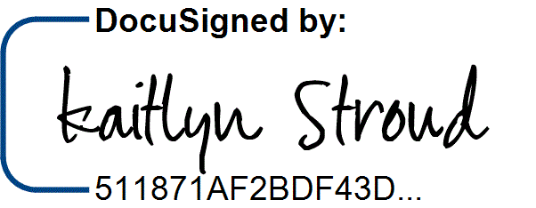Kaitlyn Stroud, Secretary